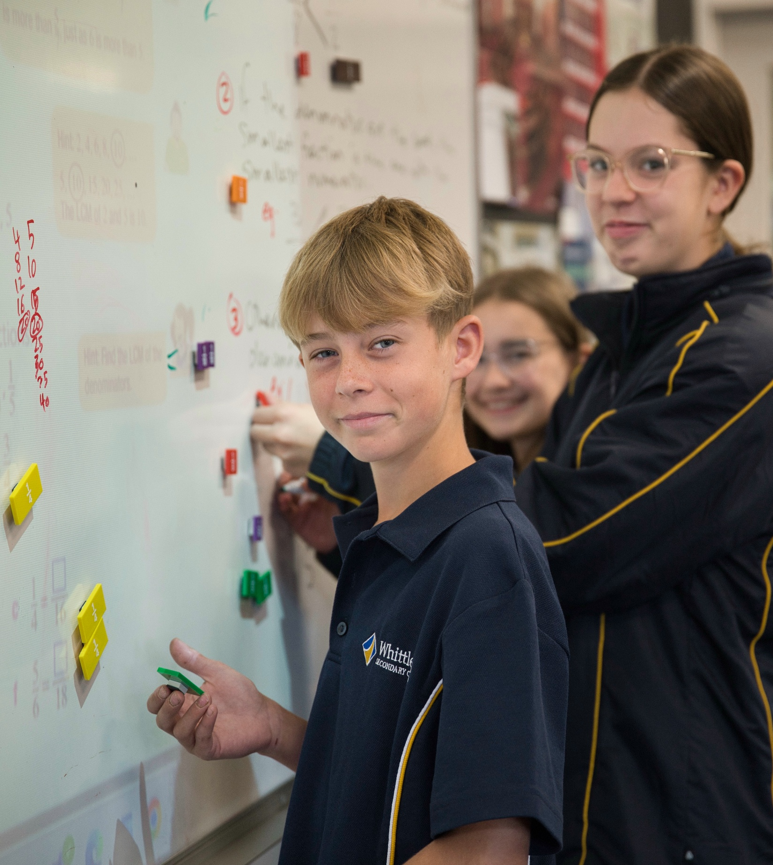



Digital Learning

Information for parents

Our commitment to the responsible use of digital technology
At Whittlesea Secondary College we are committed to building a culture of respect and responsibility. We show this in the way we use technology and interact online. We teach our students about responsible digital behaviours, including how to recognise and respond to online dangers and threats. We support our students to develop the
digital skills they need to make a positive impact in the world. We are intentional and discerning about our integration of digital tools into the curriculum, providing rich, interactive and personalised experiences, while ensuring a balance with offline learning opportunities.

What we do
 | We set clear expectations  - We have clear expectations about appropriate conduct using digital technologies.  - Our Mobile Phone Policy outlines our College’s expectations relating to students using mobile phones during school hours.  - We have clear and appropriate consequences when students breach these expectations, in line with our Student Wellbeing and Engagement Policy
We teach appropriate conduct
- We teach our students to be safe, intentional and responsible users of digital technologies, including age-appropriate instruction on important digital issues such as cybersafety and
cyberbullying.
 | We partner with families  - We work with parents and carers to understand the digital technology-related issues they are facing at home. We support them with information and tools that help.
We provide access to technology
- We provide access to educational software for students to use: Compass, Office 365, Atomi, Stile, Winc eBooks and IXL
- We create student email accounts which are non-identifiable.
We supervise digital learning
- We supervise students using digital technologies in the classroom, consistent with our duty of care. [Compass, Office 365, Atomi, Stile, Winc eBooks and IXL]
- We use clear protocols and procedures to protect students working in online spaces
 | We take appropriate steps to protect students  - We provide a filtered internet service to block inappropriate content. Full protection from inappropriate content cannot be guaranteed, however, we have processes to report and act on inappropriate content.  - We may access and monitor messages and files sent or saved our network, if necessary and appropriate.
 | We appropriately manage and respond to online incidents  - We work to prevent, respond, and learn from issues or incidents relating to the use of digital technology, including cybersecurity incidents, cyberbullying and risks to child safety.  - We refer suspected illegal online acts to the police.

How parents and carers can help
Below are our suggestions for ways you can support your children to responsibly use digital technology.

Establish clear routines
- Talk to your child about expectations including when, where, and how digital devices can be used at home, ensuring these rules are age-appropriate and consistent. These can include:
  - Requiring devices to be used in a common area, such as a living room or study area
  - Setting up a specific area for charging devices overnight, away from bedrooms, to promote better sleep hygiene.
 |  |  |  |  | Restrict inappropriate content  - Use built-in parental controls on devices and apps to help manage their device access and restrict inappropriate content.  - Consider restricting the use of apps with addictive game mechanics (e.g. rewards, badges, limited exit options).
Talk about online safety
- Talk with your child about the importance of protecting personal information, recognising online scams, and understanding and adjusting privacy settings in online spaces.
- Talk with your child about age restrictions on social media and explore other ways they can connect with their friends online and offline.
- Encourage your child to talk to you or another trusted adult if they feel unsafe online.
Model responsible and balanced technology use
- Encourage a healthy balance between screen time and offline activities, especially outdoor unstructured play and time with friends and family, face-to-face.*
- Demonstrate responsible and balanced tech use in your own daily routine to set a good example for your child.
 |  |  |  |  | Work with us  - Let your child’s teacher know about concerns you have regarding their technology use  - Keep informed about what your child is learning at school, so you can help reinforce positive messages at home.
*Australia’s physical activity and sedentary behaviour guidelines include the following recommendations for children between 5-17 years-old regarding sedentary recreational screen time:
- no more than 2 hours of sedentary recreational screen time per day
- avoiding screen time 1 hour before sleep
- keeping screens out of the bedroom.
Source: Australia’s physical activity and sedentary behaviour guidelines, https://www.health.gov.au/topics/physical-activity-and-exercise/physical-activity-and-exercise-guidelines-for-all-australians/for-children-and-young-people-5-to-17-years.

Support for parents and carers
To learn more about how to support the safe, intentional and responsible use of digital technologies at home, the eSafety Commissioner provides advice for parents, and outlines available counselling and support services.

Personal devices at Whittlesea Secondary College
Whittlesea Secondary College operates a Bring Your Own Device (BYOD) program. Parents/carers are invited to purchase or supply a device for their child to bring to school. We have made special arrangements with JB HiFi who offer discounted prices for the lease or purchase of devices for our students. E Learning BYOD Program
Technical specifications for BYOD devices
To ensure smooth and reliable technology access and student support, we have set the following technical
specifications for all approved devices. If purchasing or supplying a personal device to use at Whittlesea Secondary College please ensure that it complies with the following specifications:

Behavioural Expectations – Personal devices
When bringing a personal device to the College students must ensure that:
- it is fully charged each morning
- it is carried to the College with appropriate care in a carry case and stored in lockable storage when not in use
- any physical device damage is immediately reported and if necessary, repaired
- it is clearly labelled with the student’s name and class
Supports and services provided
Whittlesea Secondary College will provide the following technical support services for personal devices brought to the College:

- Support to access software [Compass, Office 365, Atomi, Stile, Winc eBooks and IXL]
- Connecting devices to the internet (we do not support ipads or tablets)
- Providing student log-in credentials to access the College’s network, including a school email account

Highly recommended device features:
- Intel Core i5 CPU or AMD Ryzen 7
- 16GB RAM
- 512GB SSD
- 13.3”+ screen
- Windows 10/Windows 11
Or Apple Macbook
- Retina display with True Tone
- Apple M1/M1 Pro/M2 Chip
- MacBook Air or MacBook Pro
- 7-core GPU or more
- 8GB+ Memory
- 256GB of SSD storage

- Required device features:
- Intel Core i5 CPU or AMD Ryzen 5
- 8GB RAM
- 256GB SSD
- 13.3”+ screen
- Windows 10
- Dual-band wireless network adapter that supports 802.11ac (Wi-Fi 5)

Please note that our College does not have insurance to cover accidental damage to students’ devices, and parents/carers are encouraged to consider obtaining their own insurance for their child’s device.
Students, parents and carers who would like more information or assistance regarding our BYOD program are encouraged to contact the General Office. Ph. 97191200.

Student and Parent ICT Acceptable Use Agreement

Digital Citizenship Commitment

At Whittlesea Secondary College, we believe that digital learning is an extension of our College values: Attitude, Achievement and Application. We are committed to creating a safe, respectful and responsible digital environment
where every member of our community demonstrates integrity, inclusion and high expectations. Digital citizenship
means using technology to support learning, protect wellbeing, show respect to others, and contribute positively to
our College community.

Student Agreement

I understand that my device must connect only through the school Wi-Fi and Department secure servers. I will use
Microsoft 365 and other platforms are responsible and for educational purposes. I will uphold the values of Attitude, Achievement and Application in digital environments. I will not engage in cyberbullying, access inappropriate content, misuse digital tools, record others without consent, or attempt to bypass College network security.
(This has been discussed and agreed/signed in class and will be pinned to students compass files)

Parent/Guardian Agreement

I understand that Whittlesea Secondary College operates a Bring Your Own Device model and that all network use is filtered and monitored through Department secure servers. I support the school in promoting responsible digital citizenship and in enforcing staged consequences where necessary. I will work collaboratively with the College to
address any breaches.

Consequences Acknowledgement

I acknowledge that breaches of this agreement may result in removal of Microsoft Teams access, parent contact, referral to the eSafety Commissioner, College disciplinary action under the Student Engagement and Wellbeing Policy, or referral to Victoria Police where required.

Signatures will be obtained in class and via a COMPASS event.

