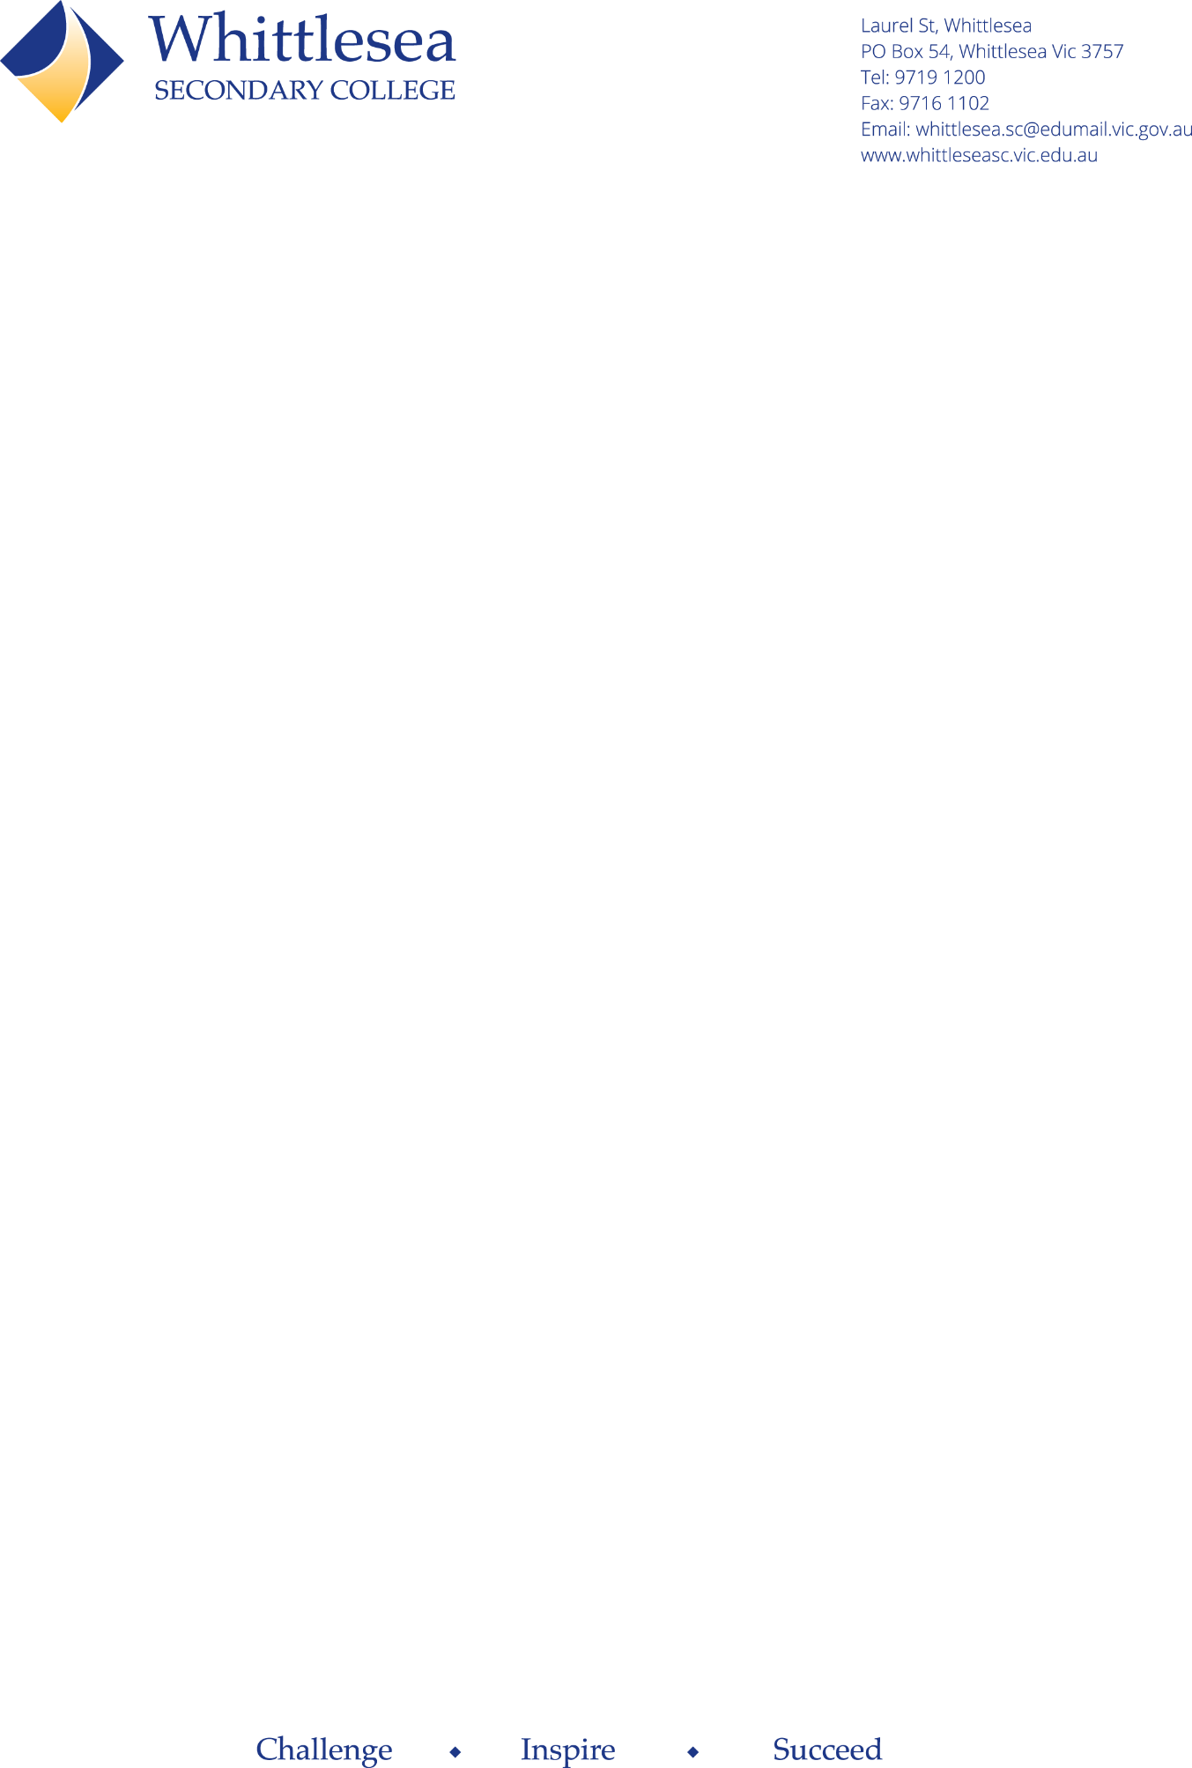

**Maths resources**

**Below is a list of resources you may choose to access to support your child’s learning at home.**

**Worksheet websites**

Sometimes students may need additional practice on a skill or concept. The below websites offer free worksheets, with answers, you may access to support your child’s learning.

* Maths is fun - <https://www.mathsisfun.com/worksheets/index.php>
* Maths salamanders - <https://www.math-salamanders.com/>
* K5 learning - <https://www.k5learning.com/free-math-worksheets>
* Maths drills - <https://math-drills.com/>
* Maths aids - <https://www.math-aids.com/>

**Workbooks**

* Excel
  + This company has a great range of Math books from year 1 to year 12.
  + They have different series depending on what you are looking for.
    - The ‘Basic skills’ series
    - The ‘Essential skills’
    - The ‘Advanced skills’ series
    - The NAPLAN style tests. <https://pascalpress.com.au/excel/?_bc_fsnf=1&SUB+BRAND%5B%5D=Excel+Essential+Skills&SUB+BRAND%5B%5D=Excel+Advanced+Skills&SUB+BRAND%5B%5D=Excel+NAPLAN%2A-style+Tests>
* Many stores also stock similar resource books for numeracy skills and NAPLAN practice.
  + Post Office outlets
  + Kmart <https://www.kmart.com.au/category/home-and-living/educational-books/>
  + Big W <https://www.bigw.com.au/books/childrens-books/education-books/maths-numeracy/c/780204100?filter%5BinStock%5D=false>
  + ALDI (special buys sometimes have great resources)
  + Office works <https://www.officeworks.com.au/shop/officeworks/c/education/numeracy/numeracy-workbooks-textbooks>

**\*\* All above listed options are only recommendations and families need to do their own research into an option that is right for their child and circumstances.**